Task 1

Lab 1: Friis Free Space Propagation Model

Name : abdelrahman matarawy Sayed

Section : 5

* **Objectives:**
  + Understanding the Friis free space Model
  + To determine the free space loss and the power received in different environments using MATLAB
  + Observing the effect of shadowing on the received signal
* **Summary**:
  + Friis free space propagation model is used to model the LOS path loss incurred in a free space environment, devoid of any objects that create absorption, diffraction, reflections, or any other characteristic-altering phenomenon to a radiated wave. It is based on the inverse square law of distance which states that the received power at a particular distance from the transmitter decays by a factor of square of the distance.
* **The Friis equation for received power is given by:**

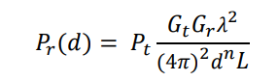

“The parameter n is the path-loss exponent that takes constant values depending on the environment that is modeled.”

* **Task (1):**
  + consider a Zigbee (IEEE 802.15.4 standard) transmission-reception system operating at f = 2.4 GHz or f = 915 MHz bands with 5 mW output power from the transmitter. The transmitter and the receiver are using an isotropic antenna. The system losses (transmission lines and antennas) are modelled by considering L = 1.4.

1. Implement the Friis propagation model using a MATLAB function.

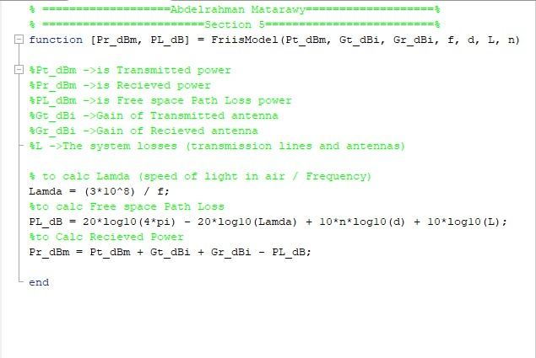

1. Plot the received power and the path loss versus distance if the channel environment is:
2. Free space:
   * Code:

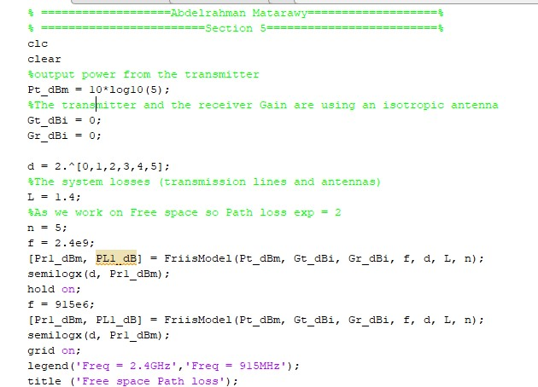

* OutPut:

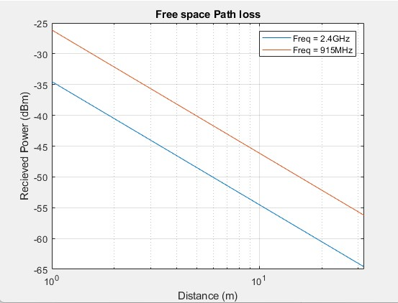

1. Obstructed by a building.

* By change n to be between 4 and 6

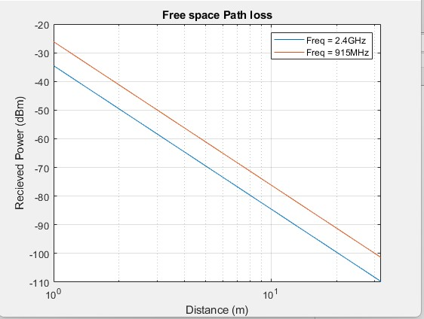

1. If the receiver sensitivity is -92dBm, the maximum range for this system at free space n = 2:

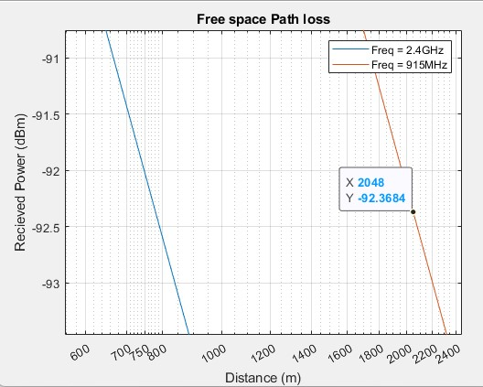

* We Found that approximately at frequency = 2.4GHz and receiver sensitivity is -92dBm, The Max distance equal 750m
* We Found that approximately at frequency = 915MHz and receiver sensitivity is -92dBm, The Max distance equal 2000m

1. If the receiver sensitivity is -92dBm, the maximum range for this system Obstructed by a building n = 5:

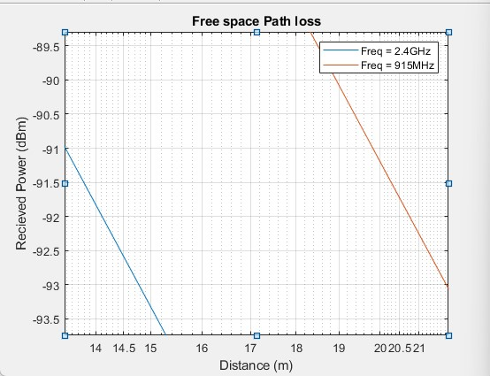

* We Found that approximately at frequency = 2.4GHz and receiver sensitivity is -92dBm, The Max distance equal 14.2m .
* We Found that approximately at frequency = 915MHz and receiver sensitivity is -92dBm, The Max distance equal 20.7m .